Welcome to XMind Workbooks Wiki



This wiki will show you how to use workbooks, maps and templates in XMind.

**Map Structures**

**Summary**

In this section you will find how to structure a map.

**Prerequisites**

There are 16 types of maps and chart structures in XMind that can be applied. They are:

* Map
* Balanced Map
  + Up to down
  + Clockwise
  + Anticlockwise
* Org Chart
  + Up to down
  + Down to up
* Tree chart
  + Right
  + Left
* Logic Chart
  + Right
  + Left
* Timeline
  + Horizontal
  + Vertical
* Fishbone
  + Left Headed
  + Right Headed
* Matrix
  + Row
  + Column

*Note: you can change not only the map’s structure, but the branches as well.*

**Applying a map structure**

In order to apply one of these structures from scratch, follow these steps:

1. Click on **New**
2. A window with different structures will appear. From there, **select** the structure you want.

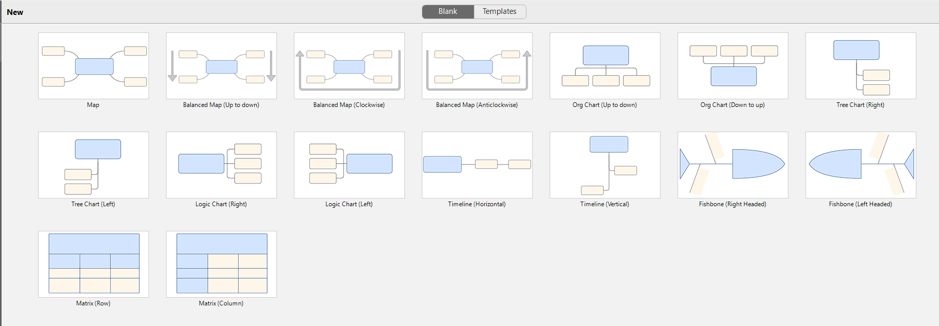

**Changing the map structure**

It is possible if you already applied a map structure to change it later.

**Steps**

1. Select **Central Topic**
2. Right click on **Central Topic** and click on **Structure**
3. Choose the structure you want from the drop-down list

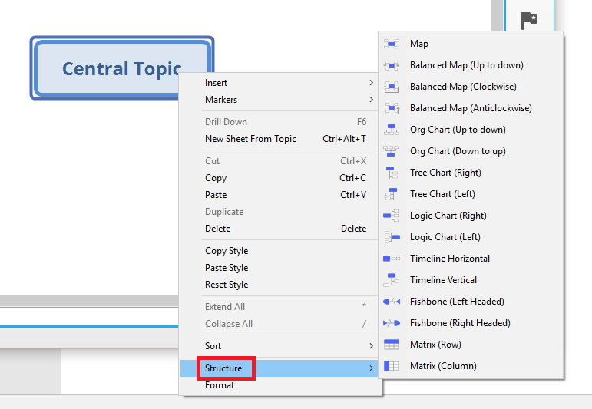

**Map Properties**

**Summary**

Here you will find how to change the settings of your map.

**Steps**

1. Right click on blank place
2. Select **Format**

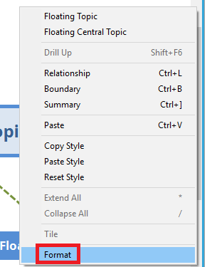

1. On the right side of the program, a new window, called **Sheet Format** will appear:

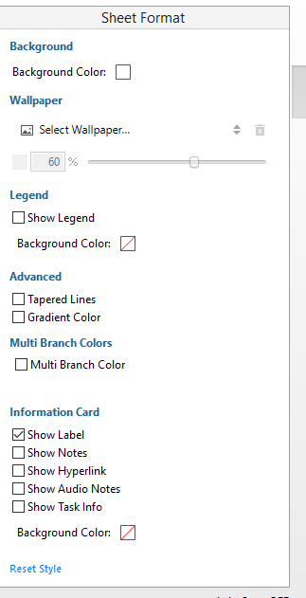

Through it, you can:

* Change the “Background Color”
* Select a wallpaper
* Legend: check or uncheck box depending if you want to show the legend or not. Also, you can change the background color for the legend.
* Advanced: check or uncheck boxes for “Tapered Lines” and “Gradient Color”.
* Multi Branch Colors: check or uncheck the box for “Multi Branch Color”.
* Information Card: check or uncheck boxes for “Show Label”, “Show Notes”, “Show Hyperlink”, “Show Audio Notes”, “Show Task Info” and add a specific background color for the Information Card.
* “Reset Style” – return to default settings.

**Reference:**

To change the map’s structure click here.

**Map Navigation**

**Summary**

Here you will find out how to jump into topics in the map and how to zoom in or out the map.

**Navigation on mind map**

Use the arrow keys in order to go through different topics in the map

**Zooming in / out**

In order to zoom in or out the map, use one of the following options:

* Use the mini toolbar that is placed below the map editor in order to zoom the map:



* Use the CTRL + Mouse Wheel shortcut
* In the menu bar, click on **View** and select between **Actual Size, Zoom In, Zoom Out, Fit Map** or **Fit Selection**

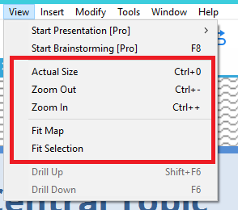

**References:**

**Wallpapers**

**Summary**

Here you will find out how to change the background image / color of your mind map.

**Prerequisites**

1. In order to add a wallpaper, you need to create a map first

**Adding a wallpaper**

* Select the map you want to customize the background for.
* Right click on any blank space and click on **Format**
* Under **Wallpaper** click on **Select Wallpaper….**

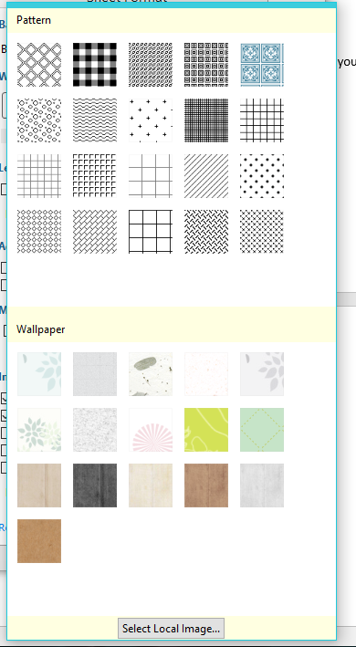

Here you can find some patterns or wallpapers that are ready to be used.

However, you can use your own image as a background. In order to do that, click on **Select Local Image** button that is under the wallpapers.

**Modifying or deleting the existing wallpaper**

* Select the map you want to modify
* Right click on it and select **Format**
* Use the slider in order to change the opacity of the background or enter the value manually through the rectangle on the left side of the slider

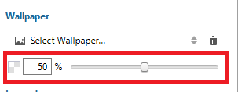

* In order to delete the wallpaper, click on the delete icon next to the Select Wallpaper….

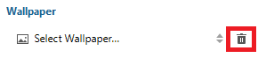

**Alignment**

**Summary**

Here you will find out how to align topics that are on the map.

**Steps:**

1. Select the topics you want to align.
2. From the menu bar, click on **Modify** and select one of the following options:

* **Align Floating Topic** 
  + **Left -** to make the selected topic blocks left aligned.
  + **Center -** to make the selected topic blocks center aligned.
  + **Right -** to make the selected topic blocks right aligned.
  + **Top -** to make the selected topic blocks top aligned.
  + **Middle -** to make the selected topic blocks middle aligned.
  + **Bottom -** to make the selected topic blocks bottom aligned.

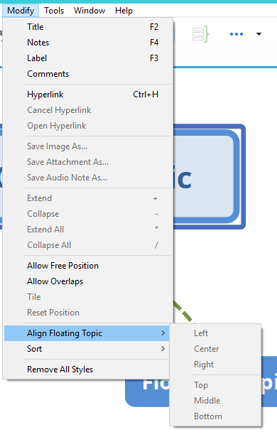

* Click on **Allow Overlaps** in order to allow topic blocks to overlap one another

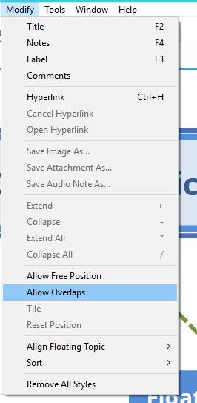

* Click on **Tile** if you want to arrange the topic blocks in tiles.

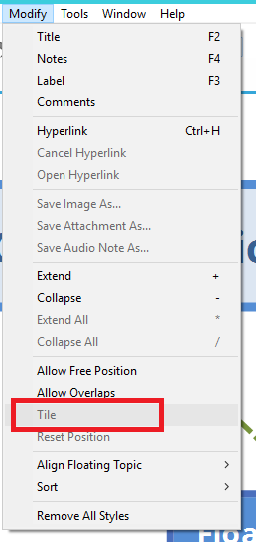

* Click on **Reset Position** if you want to reset the block to its default position.

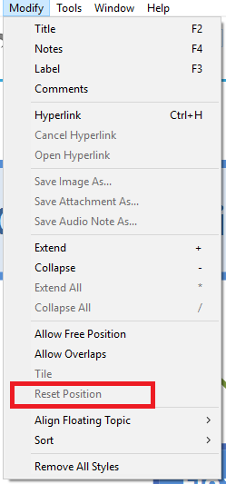

**Themes**

**Summary**

Here you will learn how to use themes in XMind.

A theme is a collection of graphical attributes of a map, such as:

* Colors
* Shapes
* Line patterns

**Changing a theme**

**Steps:**

1. Choose **Window** from the menu bar
2. Select **Themes**

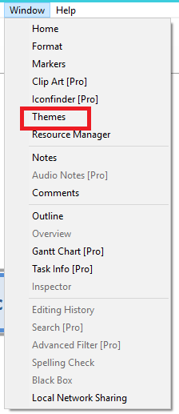

1. A new window on the right side will appear. From there, you can choose a different theme to apply by double clicking on it.

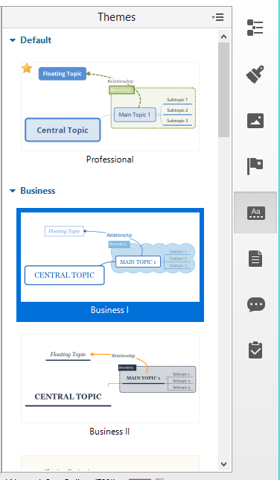

**Types of themes**

There are different types of maps, which can be further customized.

The included themes in XMind are grouped into:

* Default
  + Professional
* Business
  + Business I
  + Business II
  + Business III
  + Business IV
  + Business V
  + Business VI
* Personalized
  + Mango
  + Neon Yellow
  + Green Tea
  + Cartoon
  + Wisteria
  + CoolMint
  + Blossom I
  + Blossom II
  + Blueprint
  + Autumn
  + Pastoral
  + Blue and White
  + Chalk
  + Secret
  + Ink Painting
* Classic
  + Professional
  + Light
  + Classic I
  + Classic II
  + Classic III
  + Academies
  + Vintage
  + Simple

**Applying a theme**

In order to apply a theme, follow these instructions:

1. Create a new **map**
2. On the pop-up window, select one of the themes which you want to use
3. Click **Create**

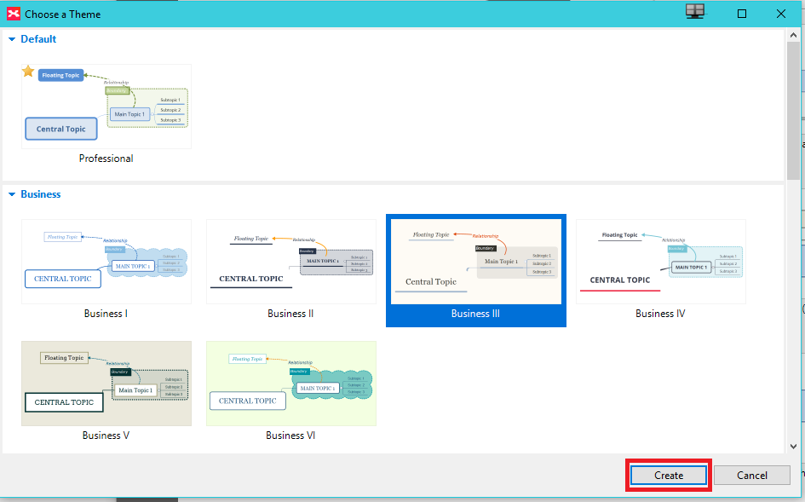

**Extracting a theme**

After you have created your theme, you have the option to extract it.

**Steps**

In order to **extract the theme**, click on Tools from the menu bar and then **Extract Theme**

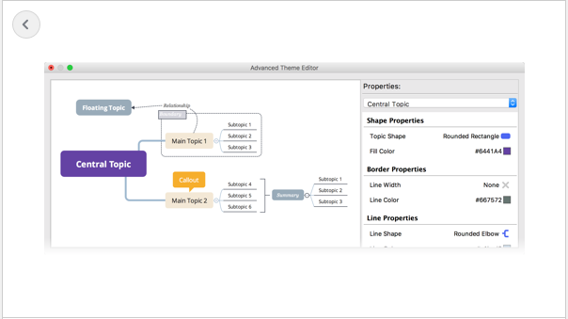

*Note: you need to unlock the pro features in order to extract your theme.*